Title: | Door Control Unit  SW Component DCM_App Version 1.2

History
Issue status  (Index) | Maturity/Date  (draft/invalid/valid)  (dd-mmm-yyyy) | Author  Department | Check/Release  Department | Description
1.0 | Draft  04-0ct-20 | Miguel Garcia | Miguel Garcia | Creation of the document
1.1 | Valid  28-Jan-2021 | Shiomar Salazar |  | First release of the SDD Document for DCM_App.
1.2 | Valid  25-03-2021 | Shiomar Salazar |  | Update after Implementation

Table of Contents
1 Purpose 3
2 Definitions and abbreviations 3
2.1 Definitions 3
2.2 Abbreviations 3
2.3 References 3
3 Realization, constraints and targets 3
4 SW Conceptual design 4
4.1 4 Use Case Diagram 4
4.2 Block Definition Diagram 4
5 SW Component internal breakdown 5
5.1 Functional Decomposition 5
5.2 SW Component internal breakdown 6
5.2.1 Function void DCM_App_Init (void) 6
5.2.2 Function void DCM_Process_Req (void) 6
5.2.3 Function void ManualRequest_Operation (void) 7
5.2.4 Function void RemoteRequest_Operation (void) 9
5.2.5 Function void UpdateCAN_Outputs (void) 11
5.2.6 Function void OpenCloseButton_Op (void) 12
5.2.7 Function uint8_t LockUnlockButton_Op (void) 13
5.2.8 Function void SpecialOpenCloseButton_Op (void) 13
5.2.9 Function void RearWindowLockUnlock_Op (void) 14
5.2.10 Function void savePrevCANSig (void) 15
5.2.11 Function void readInputCAN (void) 16
5.2.12 Function void LockUnlockRemote_OpBCM(void) 17
5.2.13 Function void LockUnlockRemote_OpDCM1 (void) 18
5.2.14 Function void LockUnlockRemote_OpDCM2 (void) 19
5.2.15 Function void OpenCloseRemote_OpBCM (void) 20
5.2.16 Function void OpenCloseRemote_OpPass (void) 22
5.2.17 Function void OpenCloseRemote_OpRR (void) 23
5.2.18 Function void OpenCloseRemote_OpRL (void) 24
5.2.19 Function void AutoLockRemote_Op (struct* CAN_msg) 25
5.2.20 Function bool BtnStuckLocking_Verification (void) 26
5.2.21 Function bool BtnStuckWindow_Verification (void) 27
5.2.22 Function void getRemoteFlag(void) 28
5.2.23 Function void setManualFlag(bool data) 28
5.2.24 Function void setTestFlag(bool data) 29

Purpose
This document is intended to provide a complete and necessary guide on the Software Detail Design of the DCM Application for the Door Control Module project; this document will provide different diagrams and specifications needed to implement by the DCM_App SWC, in order to fulfil all the customer requirements. In addition, this document will capture and summarize all the significant architectural decision, which have been made for this SWC.

Definitions and abbreviations

Definitions

Abbreviations
DCM | Door Control Module
SWC | Software Component
DD | Driver Door
PD | Passenger Door
RR | Rear Right Door
RL | Rear Left Door
SW | Software
HAL | Hardware Abstraction Layer

References
N° | Document name | Reference
1 | “Traceability Matrix Template.xls” Version 2 | \V_Project_UDG_Eq4\documentation\V-Cycle Process\1.0 Requirements
2 | “Proyecto_DoorControlModule.docx” | \V_Project_UDG_Eq4\documentation
3 | SWA_DoorControlModule.pdf | \V_Project_UDG_Eq4\documentation\V-Cycle Process\2.0 Architecture\

Realization, constraints and targets
DCM_App is one of the key components of the DCM project, due that this SWC component shall implement most of the customer requirements.
This SWC will be able to get all the inputs form other SWC (like Button Manager or CAN Manager) and be able to perform the necessary algorithm to perform the main three functions of the system (Door Locking feature, Window Control Feature, HW Diagnostics).
This SWC also communicate with the “output SWC” (i.e., Actuator Manager, Error Manager or Serial Manager) which help the DCM_App to trigger the expected behavior of every input combination.

SW Conceptual design

4 Use Case Diagram
The DCM_App is the main function of the DCM Project, this SWC will contain the logic functions that will implement most of the requirements, and hence this SWC will interact with most of the other SWC. In the image below the DCM_App boundaries and use cases can be seen.

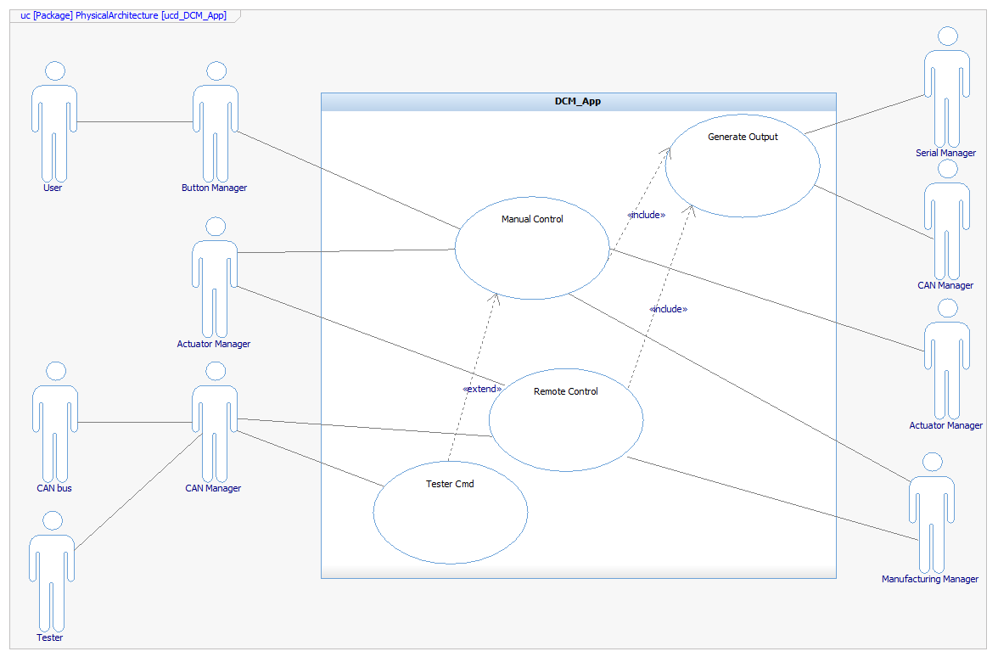

Block Definition Diagram
In the diagram below is shown the different interfaces used to communicate with the other SWC components. The DCM contain all the operation to read the inputs (both button events and CAN signal request) and can generate the expected output8like the Actuator Type of action and Which actuator, or the Error Data to be handled).
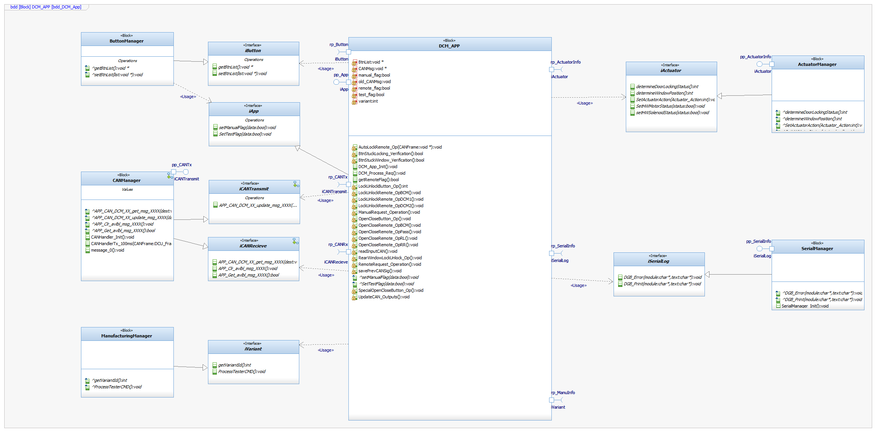

SW Component internal breakdown

Functional Decomposition

The DCM_App will contain five main function to handle the Remote-Control Operation, Manual Control Operation, to process the Tester Commands, to handle the Output for the CAN and the Serial SWC and also a Initialization function for the main five variables.
The variable will contain the relevant information like Error Info, Actuator Type, Actuator Action, the Serial Log and the CAN Frame; this variable will have a global scope inside the DCM_App SWC.

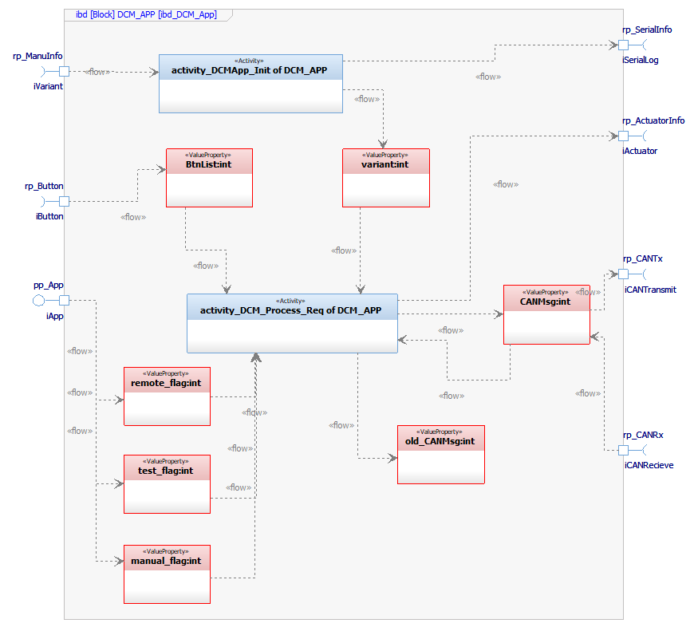

SW Component internal breakdown

Function void DCM_App_Init (void)

Description | This function performs the necessary step (Variable Initialization) to allow the algorithm to be ready to execute.
Parameter 1  void | N/A
Return Value | N/A
Precondition | The OS call this function during the initialization process, hence no preconditions.
Post condition | N/A
Error Conditions | N/A
Requirements | This Function will not implement any requirement.

Dynamic Behavior
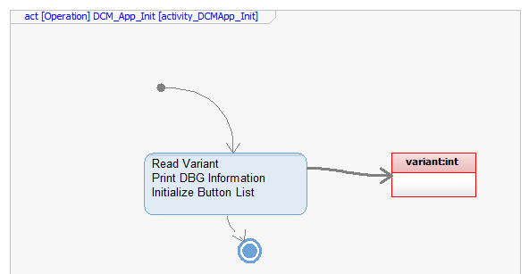

Function void DCM_Process_Req (void)

Description | This function will be executed periodically to ensure all the changes form the algorithm are properly attended.  This function will collect the information from CAN and Button Manager inputs and trigger the function accordingly.
Parameter 1  void | N/A
Return Value | N/A
Precondition | This Function shall be executed after the DCM_App_Init  This Function will be executed periodically.
Post condition | After this function has been executed, the CAN Frame and Log Variable will be populated with the expected information.
Error Conditions | Prior this function has been executed the input shall be validated by Button and CAN Manager, hence no error possible here.
Requirements | For requirement traceability, please refer to traceability matrix file (see reference section).

Dynamic Behavior
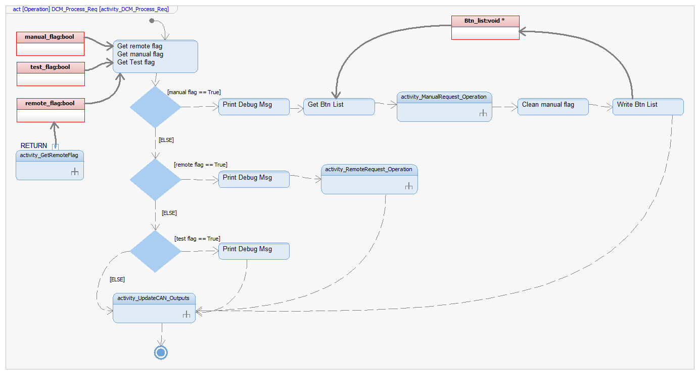

Function void ManualRequest_Operation (void)

Description | This function will trigger all the related function to attend the Manual request send over from the Button Manager, depending on the variant.
Parameter 1  void | N/A
Return Value | N/A
Precondition | This Function shall be executed after the DCM_App_Init.  Manual Flag shall be Set to True.
Post condition | After this function has been executed, the Actuator Manager shall be informed and CAN Variable will be populated with the expected information.
Error Conditions | This function will validate all the algorithm inputs, and if it encounters an error (invalid signals or impossible conditions), stop execution and perform no action.
Requirements | For requirement traceability, please refer to traceability matrix file (see reference section).

Dynamic Behavior
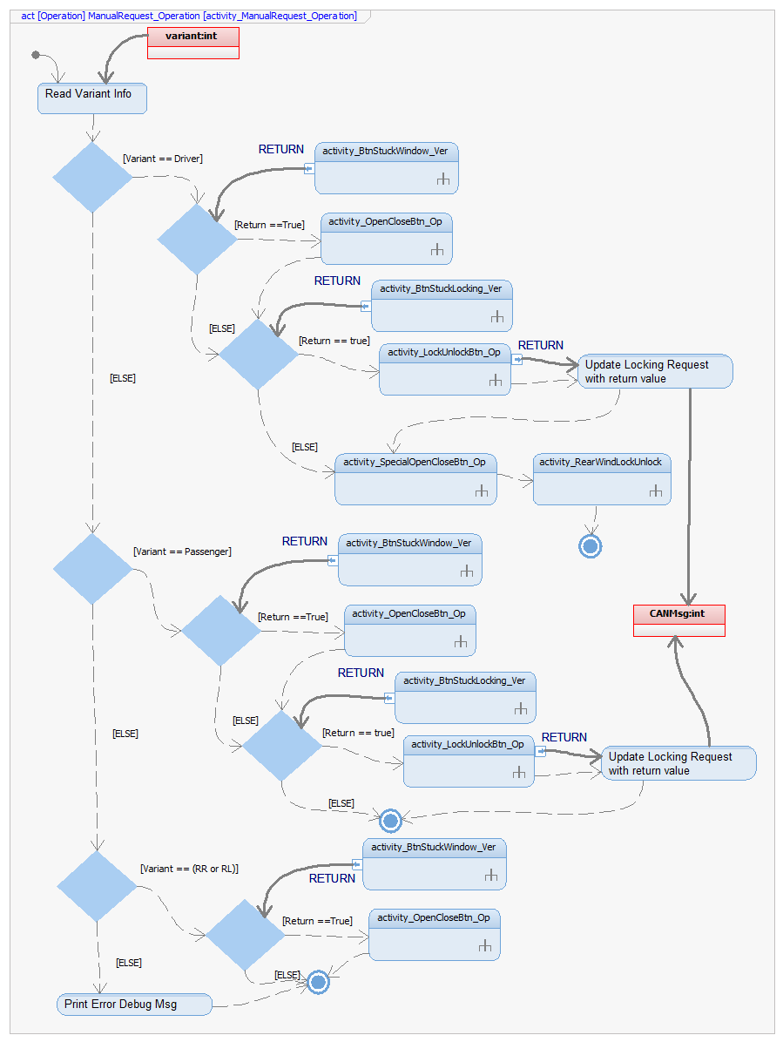

Function void RemoteRequest_Operation (void)

Description | This function will trigger all the related function to attend the Remote request send over from the CAN Manager, depending of the variant.
Parameter 1  void | N/A
Return Value | N/A
Precondition | This Function shall be executed after the DCM_App_Init.  Remote Flag shall be Set to True.
Post condition | After this function has been executed, the Actuator Manager shall be informed and CAN Variable will be populated with the expected information.
Error Conditions | This function will validate all the algorithm inputs, and if it encounters an error (invalid signals or impossible conditions), stop execution and perform no action.
Requirements | For requirement traceability, please refer to traceability matrix file (see reference section).

Dynamic Behavior
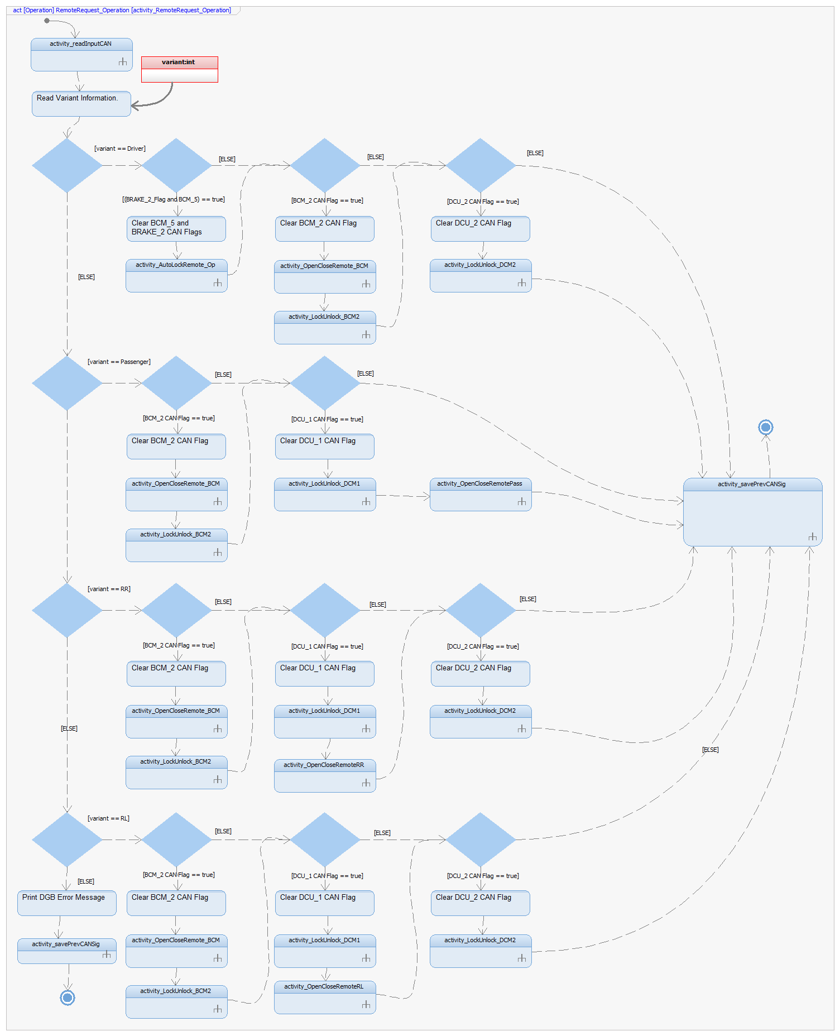

Function void UpdateCAN_Outputs (void)

Description | This function will be at the end of function DCM_Process_Req and will collect all the CAN Output related information to post the information in the Bus.
Parameter 1  void | N/A
Return Value | N/A
Precondition | This Function shall be executed after the DCM_App_Init  This Function will be executed periodically.
Post condition | After this function has been executed, the CAN Frame is present in the bus.
Error Conditions | Prior this function has been executed the input shall be validated by the previous functions on this SWC, hence no error possible here.
Requirements | For requirement traceability, please refer to traceability matrix file (see reference section).

Dynamic Behavior
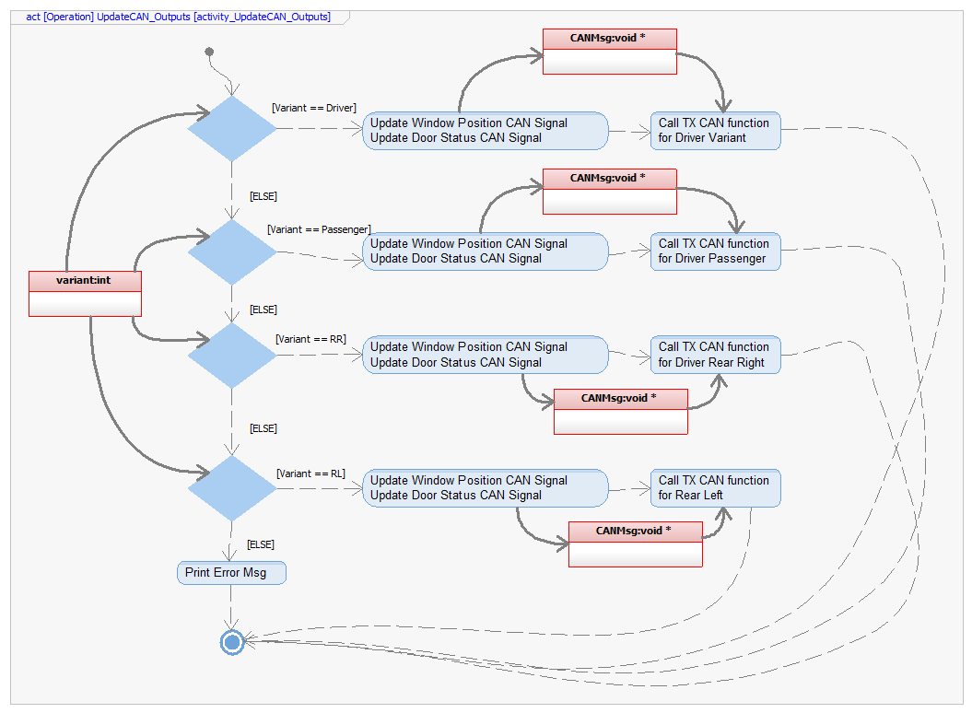

Function void OpenCloseButton_Op (void)

Description | This function will validated the information related to Open and Close Window button and will call the expected function to inform the Actuator Manager.
Parameter 1  void | N/A
Return Value | N/A
Precondition | This Function shall be executed after the DCM_App_Init  This Function will be executed only if there is no Button Stuck condition
Post condition | After this function has been executed, the CAN Frame will be populated with the expected information.
Error Conditions | No error possible here.
Requirements | For requirement traceability, please refer to traceability matrix file (see reference section).

Dynamic Behavior
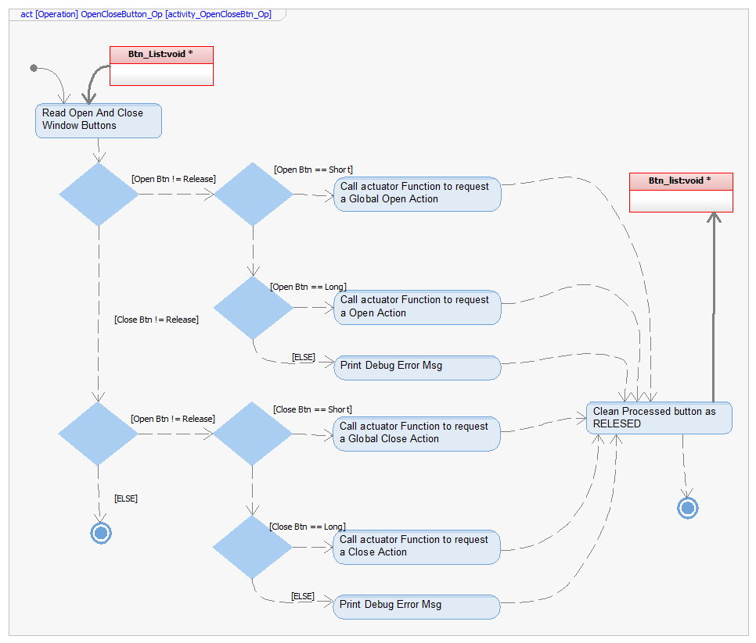

Function uint8_t LockUnlockButton_Op (void)

Description | This function will validated the information related to Lock and Unlock Door button and will call the expected function to inform the Actuator Manager.
Parameter 1  void | N/A
Return Value | Uint8_t:  Will return the status of the Door Control to send over CAN.
Precondition | This Function shall be executed after the DCM_App_Init  This Function will be executed only if there is no Button Stuck condition
Post condition | After this function has been executed, the CAN Frame will be populated with the expected information.
Error Conditions | No error possible here.
Requirements | For requirement traceability, please refer to traceability matrix file (see reference section).

Dynamic Behavior
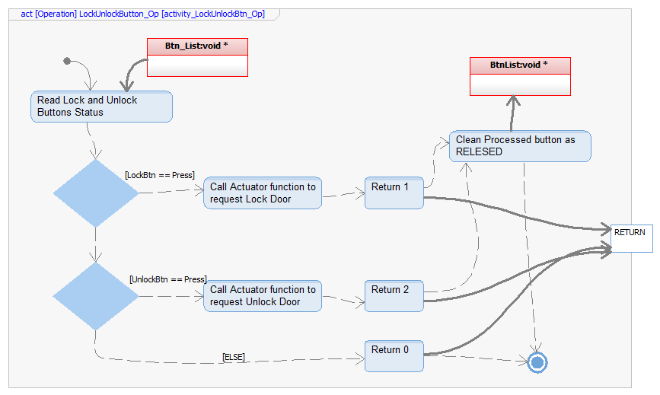

Function void SpecialOpenCloseButton_Op (void)

Description | This function will validated the information related to Driver Window Control buttons and will Updated the expected CAN Frame.
Parameter 1  void | N/A
Return Value | N/A
Precondition | This Function shall be executed after the DCM_App_Init  This Function will be executed only if the variant is Configured as Driver.
Post condition | After this function has been executed, the CAN Frame will be populated with the expected information.
Error Conditions | No error possible here.
Requirements | For requirement traceability, please refer to traceability matrix file (see reference section).

Dynamic Behavior
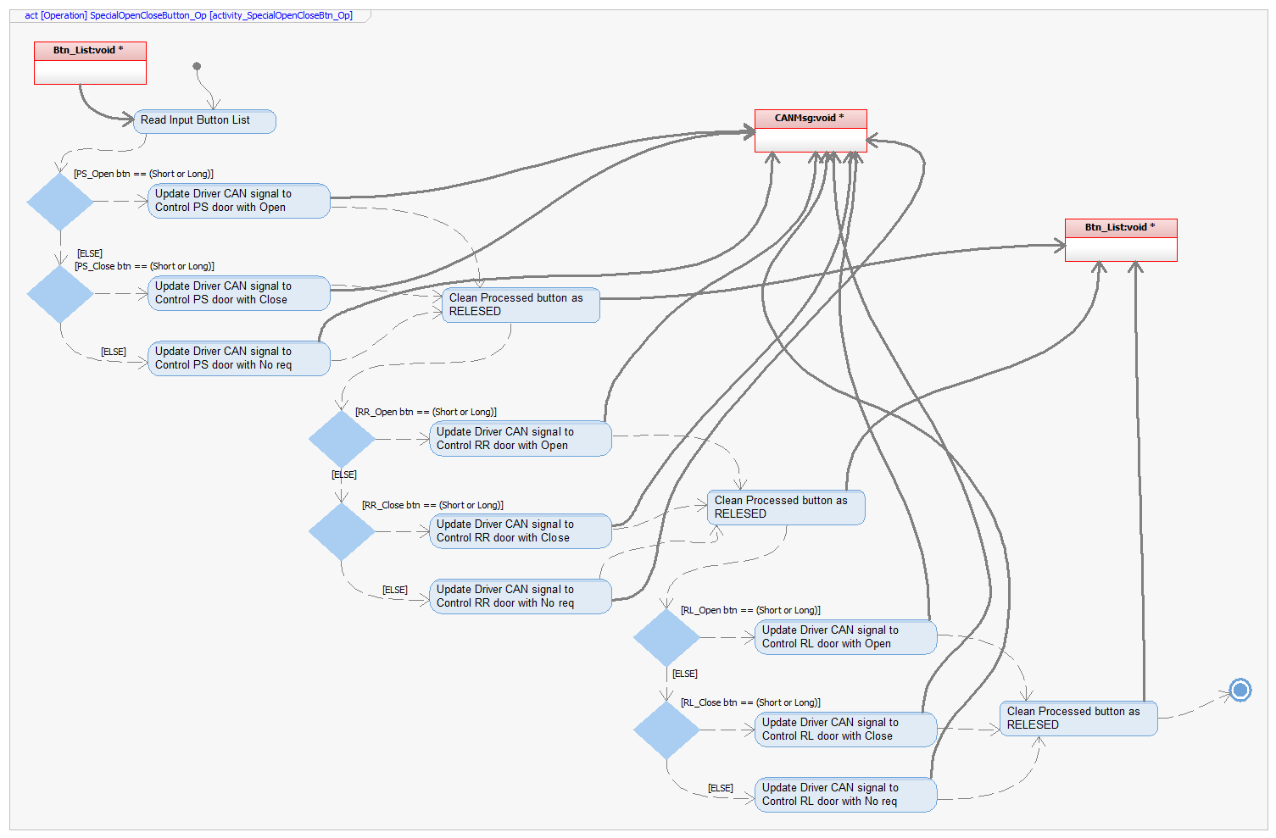

Function void RearWindowLockUnlock_Op (void)

Description | This function will validated the information related to Driver Rear Locking Control button and will Updated the expected CAN Frame.
Parameter 1  void | N/A
Return Value | N/A
Precondition | This Function shall be executed after the DCM_App_Init  This Function will be executed only if the variant is Configured as Driver.
Post condition | After this function has been executed, the CAN Frame will be populated with the expected information.
Error Conditions | No error possible here.
Requirements | For requirement traceability, please refer to traceability matrix file (see reference section).

Dynamic Behavior
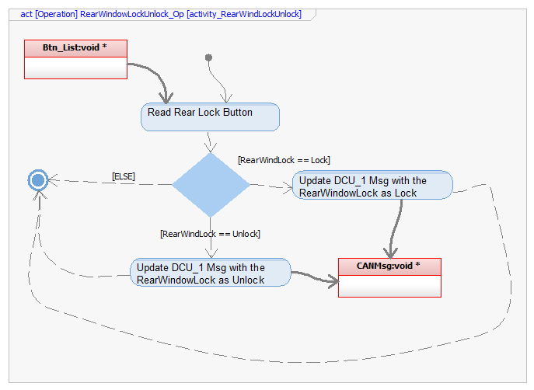

Function void savePrevCANSig (void)

Description | This function will be executed after update the CAN Frames and will save the updated value as “old” value to be able to validated the necessary transitions.
Parameter 1  void | N/A
Return Value | N/A
Precondition | This Function shall be executed after the DCM_App_Init  This Function will be executed after a Remote request was processed.
Post condition | After this function has been executed, the old CAN values will be updated.
Error Conditions | No error possible here.
Requirements | For requirement traceability, please refer to traceability matrix file (see reference section).

Dynamic Behavior
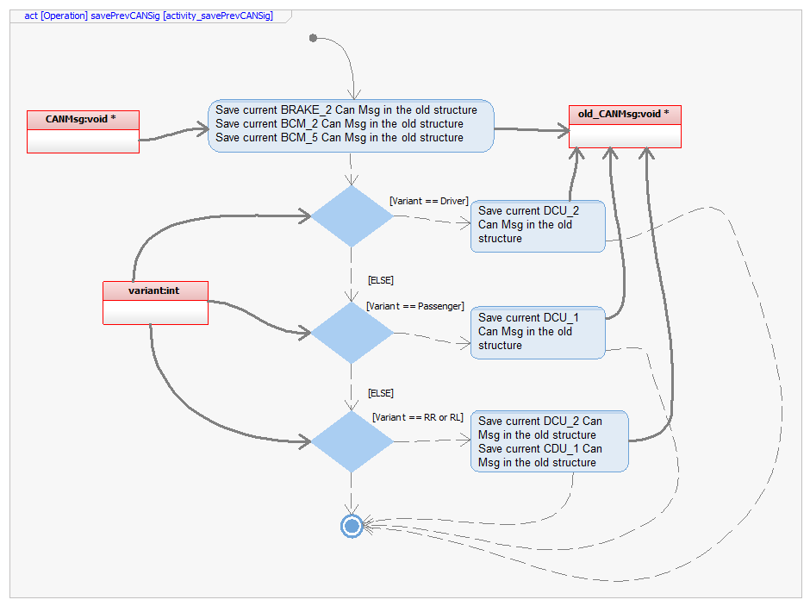

Function void readInputCAN (void)

Description | This function will be executed before a Remote Request and will collect all the values of the CAN Signals coming from the Bus.
Parameter 1  void | N/A
Return Value | N/A
Precondition | This Function shall be executed after the DCM_App_Init  This Function will be executed before a Remote request is been processed.
Post condition | After this function has been executed, the input CAN values will be updated.
Error Conditions | No error possible here.
Requirements | For requirement traceability, please refer to traceability matrix file (see reference section).

Dynamic Behavior
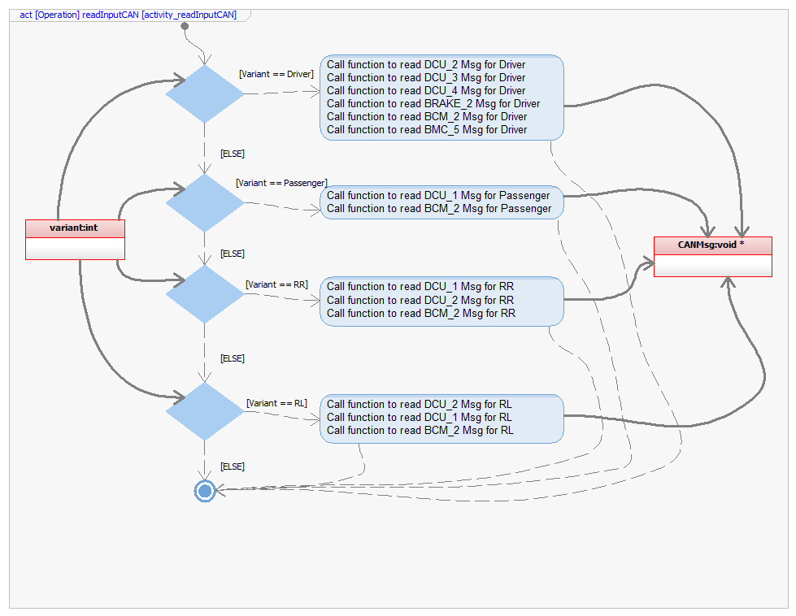

Function void LockUnlockRemote_OpBCM(void)

Description | This function will handle all the Door Control Request coming from the BCM module, will validate the transition of the signal and will inform to the Actuator Manager of the proper action.
Parameter 1  void | N/A
Return Value | N/A
Precondition | This Function shall be executed after the DCM_App_Init  This Function require the Input CAN signal be updated.
Post condition | After this function has been executed, the CAN Frame will be populated with the expected information.
Error Conditions | Prior this function has been executed the input shall be validated by the CAN Manager SWC, hence no error possible here.
Requirements | For requirement traceability, please refer to traceability matrix file (see reference section).

Dynamic Behavior

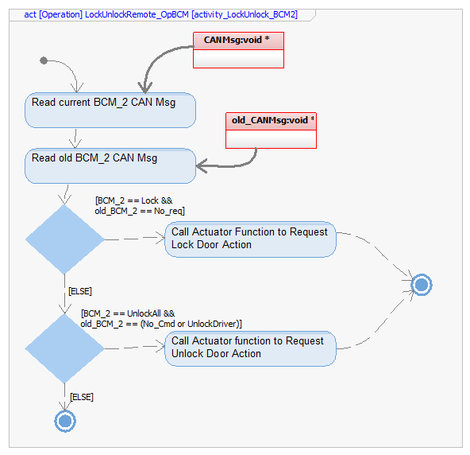

Function void LockUnlockRemote_OpDCM1 (void)

Description | This function will handle all the Door Control Request coming from the Driver DCM module, will validate the transition of the signal and will inform to the Actuator Manager of the proper action.
Parameter 1  void | N/A
Return Value | N/A
Precondition | This Function shall be executed after the DCM_App_Init  This Function require the Input CAN signal be updated.
Post condition | After this function has been executed, the CAN Frame will be populated with the expected information.
Error Conditions | Prior this function has been executed the input shall be validated by the CAN Manager SWC, hence no error possible here.
Requirements | For requirement traceability, please refer to traceability matrix file (see reference section).

Dynamic Behavior
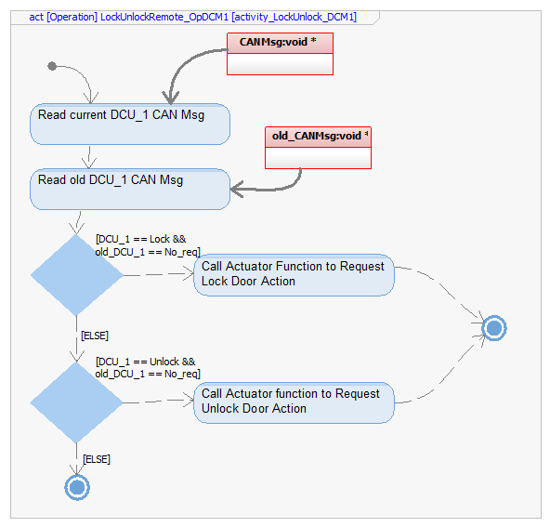

Function void LockUnlockRemote_OpDCM2 (void)

Description | This function will handle all the Door Control Request coming from the Passenger DCM module, will validate the transition of the signal and will inform to the Actuator Manager of the proper action.
Parameter 1  void | N/A
Return Value | N/A
Precondition | This Function shall be executed after the DCM_App_Init  This Function require the Input CAN signal be updated.
Post condition | After this function has been executed, the CAN Frame will be populated with the expected information.
Error Conditions | Prior this function has been executed the input shall be validated by the CAN Manager SWC, hence no error possible here.
Requirements | For requirement traceability, please refer to traceability matrix file (see reference section).

Dynamic Behavior
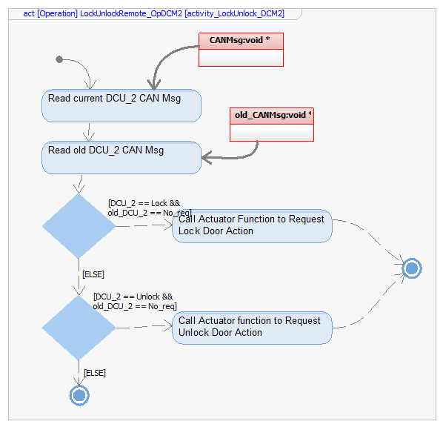

Function void OpenCloseRemote_OpBCM (void)

Description | This function will handle all the Window Control Request coming from the BCM module, will validate the transition of the signal and will inform to the Actuator Manager of the proper action.
Parameter 1  void | N/A
Return Value | N/A
Precondition | This Function shall be executed after the DCM_App_Init  This Function require the Input CAN signal be updated.
Post condition | After this function has been executed, the CAN Frame will be populated with the expected information.
Error Conditions | Prior this function has been executed the input shall be validated by the CAN Manager SWC, hence no error possible here.
Requirements | For requirement traceability, please refer to traceability matrix file (see reference section).

Dynamic Behavior
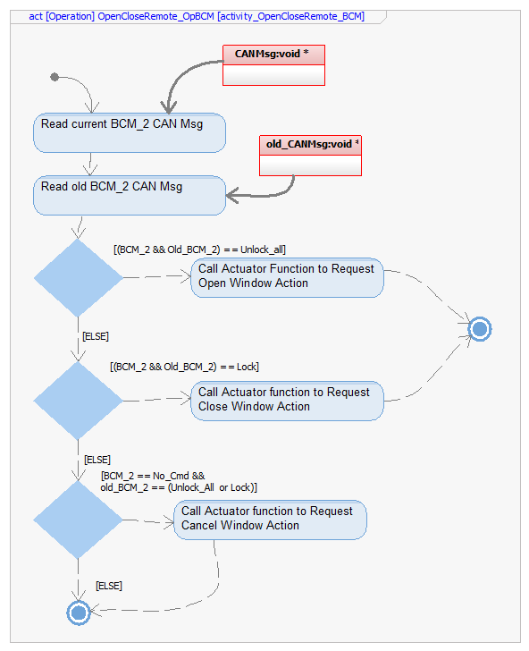

Function void OpenCloseRemote_OpPass (void)

Description | This function will handle all the Window Control Request coming from the Driver DCM module to the Passenger DCM, will validate the transition of the signal and will inform to the Actuator Manager of the proper action.
Parameter 1  void | N/A
Return Value | N/A
Precondition | This Function shall be executed after the DCM_App_Init  This Function require the Input CAN signal be updated.  This function will only be called of the Variant is configured as Passenger.
Post condition | After this function has been executed, the CAN Frame will be populated with the expected information.
Error Conditions | Prior this function has been executed the input shall be validated by the CAN Manager SWC, hence no error possible here.
Requirements | For requirement traceability, please refer to traceability matrix file (see reference section).

Dynamic Behavior
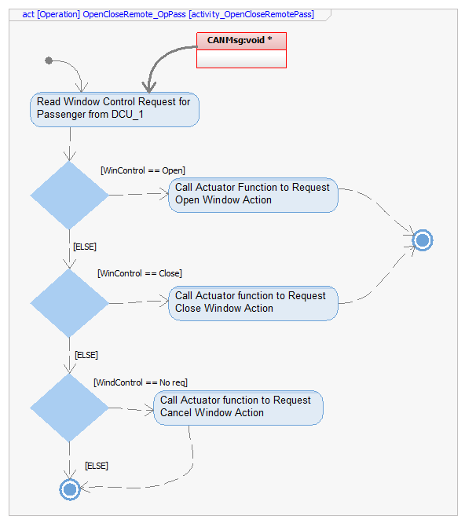

Function void OpenCloseRemote_OpRR (void)

Description | This function will handle all the Window Control Request coming from the Driver DCM module to the Rear Right DCM, will validate the transition of the signal and will inform to the Actuator Manager of the proper action.
Parameter 1  void | N/A
Return Value | N/A
Precondition | This Function shall be executed after the DCM_App_Init  This Function require the Input CAN signal be updated.  This function will only be called of the Variant is configured as RR.
Post condition | After this function has been executed, the CAN Frame will be populated with the expected information.
Error Conditions | Prior this function has been executed the input shall be validated by the CAN Manager SWC, hence no error possible here.
Requirements | For requirement traceability, please refer to traceability matrix file (see reference section).

Dynamic Behavior
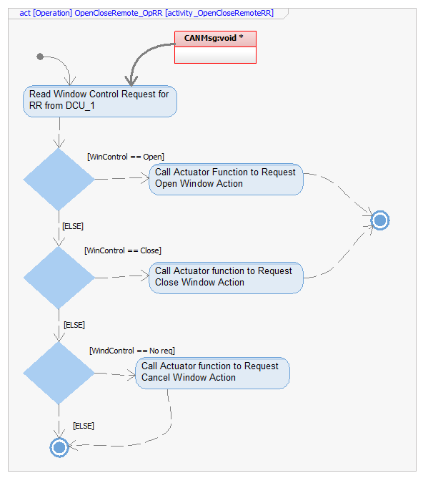

Function void OpenCloseRemote_OpRL (void)

Description | This function will handle all the Window Control Request coming from the Driver DCM module to the Rear Left DCM, will validate the transition of the signal and will inform to the Actuator Manager of the proper action.
Parameter 1  void | N/A
Return Value | N/A
Precondition | This Function shall be executed after the DCM_App_Init  This Function require the Input CAN signal be updated.  This function will only be called of the Variant is configured as RL.
Post condition | After this function has been executed, the CAN Frame will be populated with the expected information.
Error Conditions | Prior this function has been executed the input shall be validated by the CAN Manager SWC, hence no error possible here.
Requirements | For requirement traceability, please refer to traceability matrix file (see reference section).

Dynamic Behavior
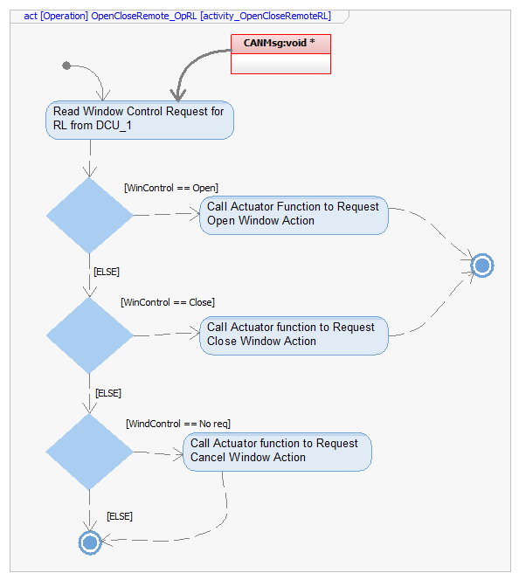

Function void AutoLockRemote_Op (struct* CAN_msg)

Description | This function will handle all the Door Control Request coming from the Brake and BCM5 module, will validate the transitions of the signals and will inform to the Actuator Manager of the proper action.
Parameter 1  struct* | CAN_msg:  Structure containing the message to be updated and send over CAN bus.
Return Value | N/A
Precondition | This Function shall be executed after the DCM_App_Init  This Function require the Input CAN signal be updated.  This Function Will only be called if the variant is configured as Driver.
Post condition | After this function has been executed, the CAN Frame will be populated with the expected information.
Error Conditions | Prior this function has been executed the input shall be validated by the CAN Manager SWC, hence no error possible here.
Requirements | For requirement traceability, please refer to traceability matrix file (see reference section).

Dynamic Behavior
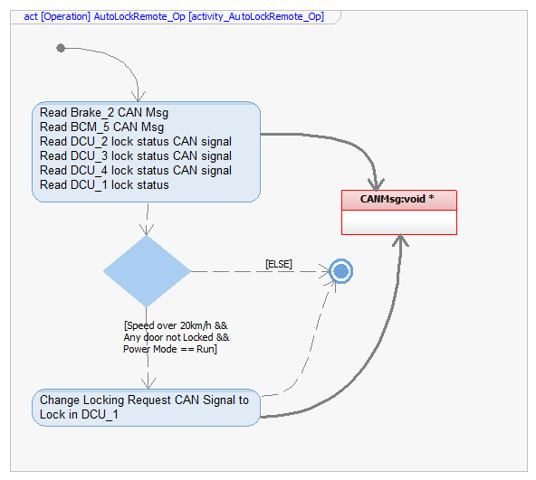

Function bool BtnStuckLocking_Verification (void)

Description | This function will be executed after a Manual request is been receiver, and will validate that the Button for Door Control are not stuck.
Parameter 1  void | N/A
Return Value | Bool:  Will return either there is a Button Stuck or not in the Button List related to the Door Control.
Precondition | This Function shall be executed after the DCM_App_Init  This Function will be executed before any manual processing.
Post condition | After this function has been, if a Button is stuck the Solenoid will be disable until next power cycle.
Error Conditions | No error possible here.
Requirements | For requirement traceability, please refer to traceability matrix file (see reference section).

Dynamic Behavior
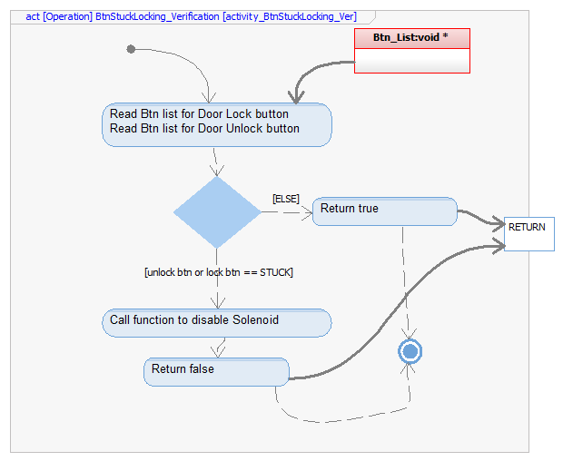

Function bool BtnStuckWindow_Verification (void)

Description | This function will be executed after a Manual request is been receiver, and will validate that the Button for Window Control are not stuck.
Parameter 1  void | N/A
Return Value | Bool:  Will return either there is a Button Stuck or not in the Button List related to the Window Control.
Precondition | This Function shall be executed after the DCM_App_Init  This Function will be executed before any manual processing.
Post condition | After this function has been, if a Button is stuck the Motor will be disable until next power cycle.
Error Conditions | No error possible here.
Requirements | For requirement traceability, please refer to traceability matrix file (see reference section).

Dynamic Behavior
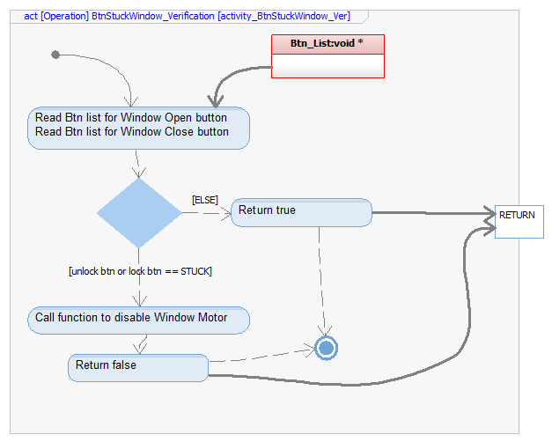

Function void getRemoteFlag(void)

Description | This function will check all the CAN flag to determine if there is a Message to be processed.
Parameter 1  void | N/A
Return Value | N/A
Precondition | This Function shall be executed after the DCM_App_Init
Post condition | After this function has been executed, remote flag will be updated to trigger the Remote Request Processing.
Error Conditions | Prior this function has been executed the input shall be validated by the CAN Manager SWC, hence no error possible here.
Requirements | For requirement traceability, please refer to traceability matrix file (see reference section).

Dynamic Behavior
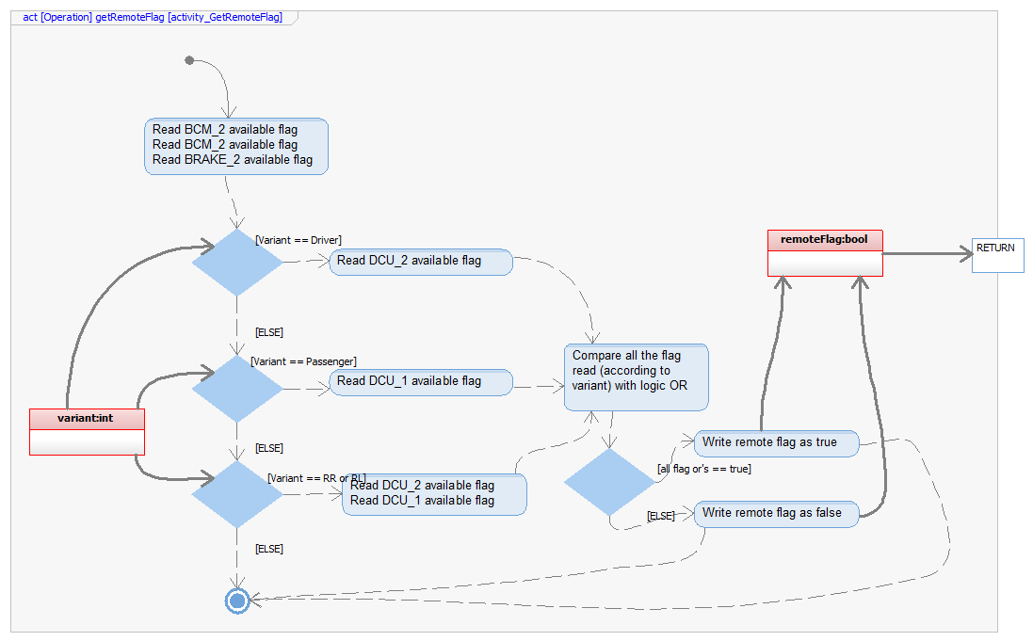

Function void setManualFlag(bool data)

Description | This function will receive the manual flag from the Button Manager to start the Manual Request Processing.
Parameter 1  bool | Data:  Processing status
Return Value | N/A
Precondition | This Function shall be executed after the DCM_App_Init.
Post condition | After this function has been executed, the manual flag will be updated to start the Manual Request processed.
Error Conditions | No error possible here.
Requirements | For requirement traceability, please refer to traceability matrix file (see reference section).

Dynamic Behavior
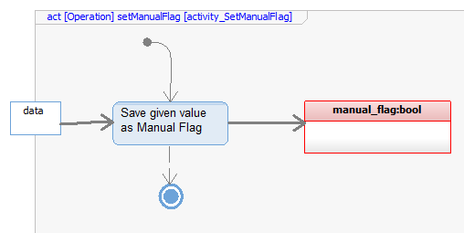

Function void setTestFlag(bool data)

Description | This function will receive the Test flag from the Manufacturing Manager to start the Manual Request Processing.
Parameter 1  bool | Data:  Processing status
Return Value | N/A
Precondition | This Function shall be executed after the DCM_App_Init.
Post condition | After this function has been executed, the Test flag will be updated to start the Tester Request processed.
Error Conditions | No error possible here.
Requirements | For requirement traceability, please refer to traceability matrix file (see reference section).

Dynamic Behavior
